* Create new folder “myapp”

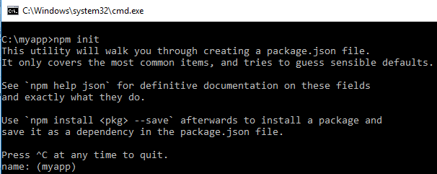

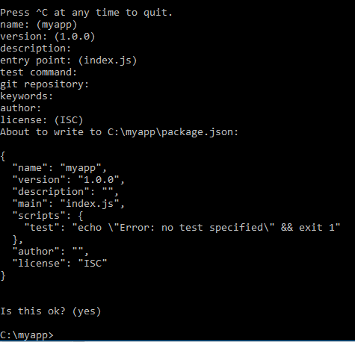

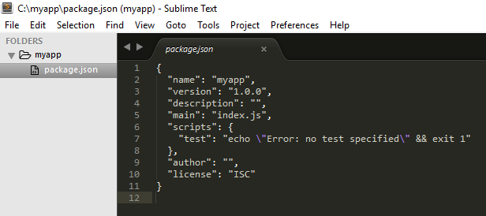

* >npm install --save-dev webpack
* >npm install --save-dev babel-core
* >npm install --save-dev babel-loader
* >npm install --save-dev babel-preset-es2015
* >npm install --save jquery

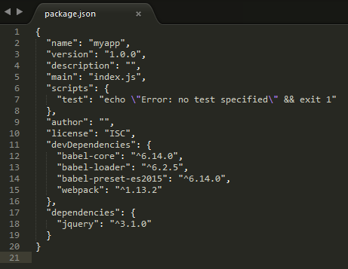

* Create “c:\myapp\src\Message.js” as follows:

export default class Message {

show(){

alert("Hello world!");

}

}

* Create “c:\myapp\src\app.js” as follows:

import msg from './Message.js'

import $ from 'jquery'

$(function(){

$("#ShowBtn").on("click", function(){

var o = new msg();

o.show();

});

});

* Create “c:\myapp\index.htm” as follows:

<!DOCTYPE html>

<html>

<head>

<title></title>

<script type="text/javascript" src="build/app.all.js"></script>

</head>

<body>

<button id="ShowBtn">Show</button>

</body>

</html>

* Create “c:\myapp\webpack.config.js” as follows:

var path = require('path');

var webpack = require('webpack');

module.exports = {

devtool: 'source-map',

entry: ['./src/app.js'],

output: {

path: './build',

filename: 'app.all.js'

},

module:{

loaders:[{

test: /\.js$/,

include: path.resolve(__dirname, "src"),

loader: 'babel-loader',

query:{

presets: ['es2015']

}

}]

}

};

